USAGE AND MAINTENANCE MANUAL

ELE

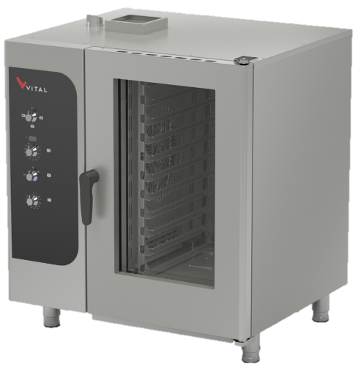
GAS CONVECTION OVEN
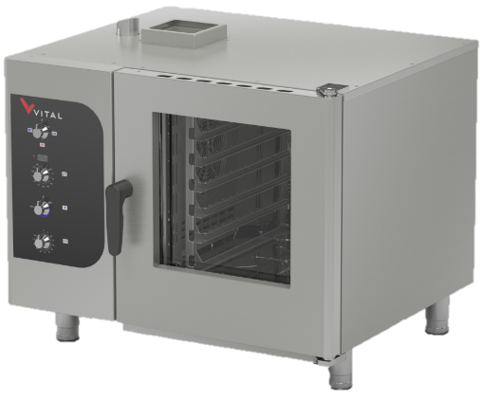

PRIME061GM PRIME101GM

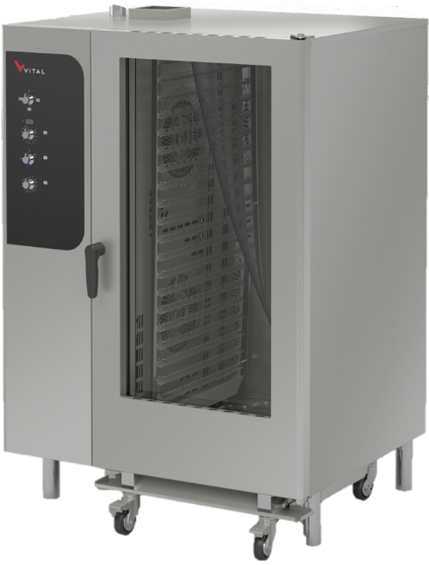

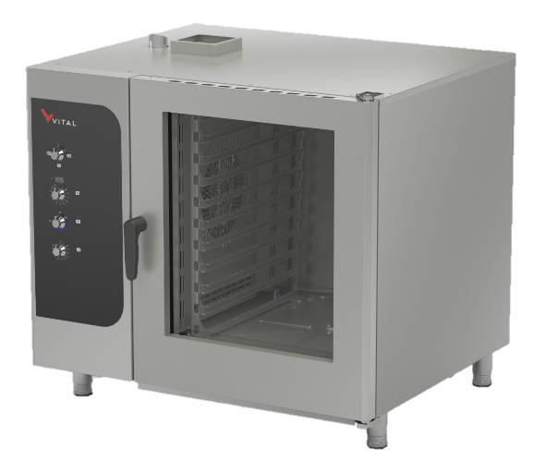

PRIME102GM PRIME202GM

PRESENTATION
DEAR CUSTOMERS,
- To get the best yield of our products that are in compliance with the International Standards, we highly recommend you to read the user’s manual and have it read to your users for long and continuous usages.
- This manual contains important informations about the secure installation, usage and maintenance of the product and necessary remarks to make the most efficient usage of your device.
- Keep this manual in an easily accessible and safe place to use when necessary.
- Our product is designed for heating and cooking food commodities. Any chemical or liquid substances or similar that can be in contact with the foodstuff, cannot be used for any heat treating that can cause damages for the health.
- The manufacturer cannot be held responsible for any damages from incorrect usage of the device, to people, the environment, or other materials resulting from translation or printing of this booklet.

INDEX

PRESENTATION 2
INDEX 3
SAFETY DETAILS 4
TECHNICAL SPECIFICATIONS 5
TRANSPORTATION, PLACEMENT AND READY TO INSTALL 7
GAS CONNECTION 8
CONTROL PANEL 10
USAGE 10
1-) Switching On 11
2-) Switching Off 11
CLEANING 12
MAINTENANCE AND MALFUNCTION 12
Problems and Solutions 12
WARRANTY CONDITIONS 13
Out of Warranty Cases 14
AUTHORIZED SERVICE START-UP PAGE 15
Start Up Page 15

Safety detaıls
- Do not expose the device to direct sunlight.
- Any kind of flammable or ignitiable solid or liquid such as alchocol and derivaritves, petro-chemical products, wood-plastic materials, curtains, clothes, etc. should not be kept in the area of the device.
- This device must be installed in accordance with the current regulations and should only be used in a well-ventilated area.
- The instructions should be analysed before the installation and the usage of the device.
- The device is designed for professional usage and should only be used by trained personnel.
- It should not be interfered without the presence of the manufacturer or the authorized service.
- The device or its components cannot be used for any other purpose.
- Apart from the heating and the cooking of the food, it cannot be used as a heater for any purpose.
- The device cannot be left uncontrolled as long as it is on.
- Food compatible gloves must be used to protect hands from the overheating.
- In case of fire or flame in the area where the device is, switch off the safety net which is located in the main circuit connection and then use the fire extinguisher. Water should absolutely not be used, otherwise the flame will sprawl faster.
- The installation and the maintenance should be carried out by the qualified staff autorized by the manufacturer. Serious danger for the user can be arise due to incorrect installations, maintenances or repairs, and the manufacturer cannot be held responsible.

TECHNICAL SPECIFICATIONS
PRODUCT CODE |  |  |  |  |  | PRIME061GM | PRIME101GM | PRIME102GM | PRIME202GM
DIMENSIONS  (mm) |  | A | WIDTH |  |  | 970 | 970 | 1200 | 1200
 |  | B | DEPTH |  |  | 880 | 880 | 1060 | 1060
 |  | C | HEIGHT |  |  | 850 | 1140 | 1140 | 1830
GAS CONNECTION |  |  |  | G-20 (NG) |  | 3/4” | 3/4” | 3/4” | 3/4”
 |  |  |  | G-30 (LPG) |  | 3/4” | 3/4” | 3/4” | 3/4”
GAS CONSUMPTION |  |  |  | G-20 (NG) | MAXIMUM | 1,482m³/h | 2,222m³/h | 3,704m³/h | 4,932m³/h
 |  |  |  |  | MINIMUM | 0,778m³/h | 1,167m³/h | 1,945m³/h | 2,589m³/h
 |  |  |  | G-30 (LPG) | MAXIMUM | 1,104kg/h | 1,656kg/h | 2,760kg/h | 3,675kg/h
 |  |  |  |  | MINIMUM | 0,580kg/h | 0,870kg/h | 1,449kg/h | 1,929kg/h
COUNTRY | AL, BG, CY, CZ, DK, EE, FI, GR, HR, IT, LT, LV, MK, NO, RO, SE, SK, SI, TR | GAS PRESSURE |  | NOMINAL | G-20 (NG) | 20 mbar | 20 mbar | 20 mbar | 20 mbar
 |  |  |  |  | G-30 (LPG) | 30 mbar | 30 mbar | 30 mbar | 30 mbar
 |  |  |  | MAXIMUM | G-20 (NG) | 25 mbar | 25 mbar | 25 mbar | 25 mbar
 |  |  |  |  | G-30 (LPG) | 35 mbar | 35 mbar | 35 mbar | 35 mbar
 |  |  |  | MINIMUM | G-20 (NG) | 17 mbar | 17 mbar | 17 mbar | 17 mbar
 |  |  |  |  | G-30 (LPG) | 25 mbar | 25 mbar | 25 mbar | 25 mbar
 |  | INJECTOR |  |  | G-20 (NG) | 1,6 mm | 2 mm | 2,6 mm | 3,2 mm
 |  |  |  |  | G-30 (LPG) | 1 mm | 1,2 mm | 1,5 mm | 1,9 mm
GAS CATEGORY |  |  |  |  | II_{2H3B/P}
TOTAL HEAT CAPACITY |  |  |  |  |  | 14 kW | 21 kW | 35 kW | 46,6 kW
ELECTRICAL INLET |  |  |  |  |  | 220-230 VAC 1N 50 Hz
CABLE CROSS SECTION |  |  |  |  |  | 3*1,5 mm² | 3*1,5 mm² | 3*1,5 mm² | 3*1,5 mm²
MOTOR POWER |  |  |  |  |  | 650 W | 650 W | 650 W | 2*650=1300W
WEIGHT |  |  |  |  |  | 115 Kg | 130 Kg | 155 Kg | 250 Kg

B
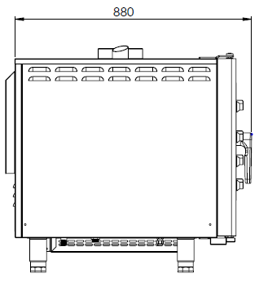
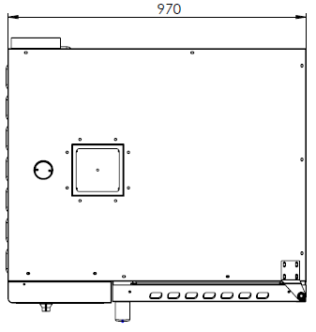
A
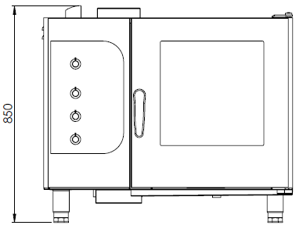

C

PRIME061GM

B
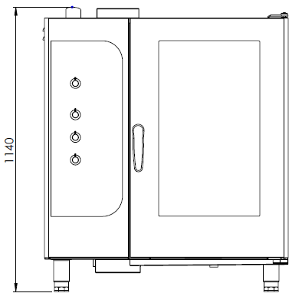
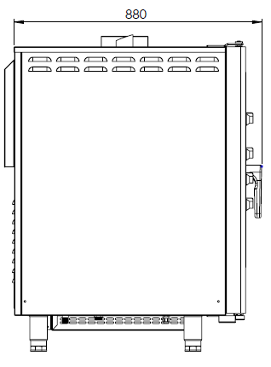
A

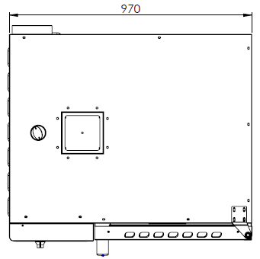
C

PRIME101GM
B
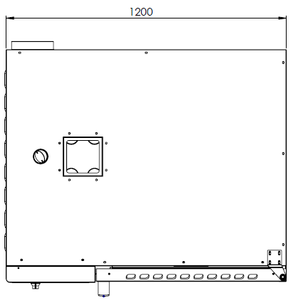
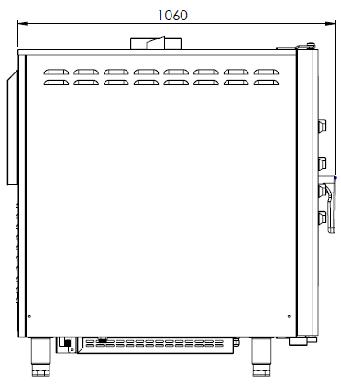
A
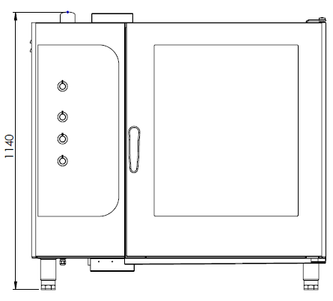

C

PRIME102GM
B
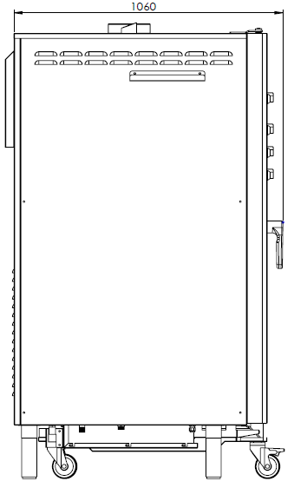
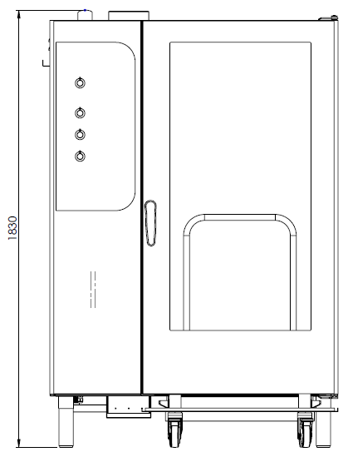

A
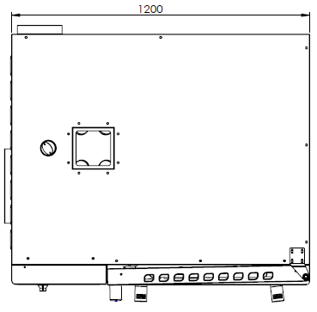
C

PRIME202GM

transportatıon, placement and ready to ınstall
- Do not tilt the device during the transportation, carry it upright.
- Use a suitable vehicle to avoid any kind of damages.
- Do not push or drag the device to bear.
- When transporting by pallet jack or forklift, make sure to not damage the device.
- Carry the device with its packaging until the installation area.
- It should be placed under a ventilation system to avoid any kind of bad smell that may occur during cooking process.
- It is recommended to place a suitable sized hood for the ventilation over the device without blocking the outlet of the chimney.
- In case the device is installed next to a wall, a partition, a kitchen furniture etc., make sure they are made by non flammable material or with a suitable thermal insulation coating with a margin of 10 cm, otherwise with a margin of 30 cm.
- Never place a combustible material on top of the device.
- Make a general cleaning before the first usage. You may use soapy water.
- The operating environment and the ventilation system of the device must be between 10°C to 40°C and have a maximum humidity level of %80.
- The device must be installed in accordance within the instructions.
- The protective film on the surface of the device must be stripped off carefully.
- Convenient gas connection with the required technical specifications must be installed in the area of the device.

gas connectıon
- Convenient gas fittings must be done as written on the product tag.
- Gas pressure corresponding to the gas type as stated on the technical specifications, should be adjusted using the appropriate regulator capacity.
- An appropriate EN 331 Standard valve must be used before the gas inlet of the device.
- The gas connection must be done according to EN 14800 Standards, with a maximum length of 120 cm metal hose.
- Check on the possible gas leackage at the end of the transition.
- Check the gas leackage with a foamy water or a gas leack detector. In case of leackage (foaming will occur on the foamy part or the gas leack detector will give a warning signal), do not use fire, and consult your seller.
- If the device is connected to a gas installation, the inlet of the gas should be designed to not reduce the gaseous flow rate.

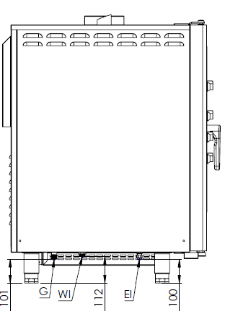
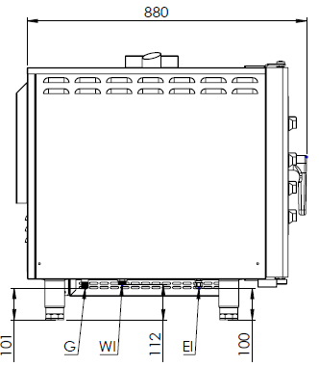

PRİME061GM PRIME101GM

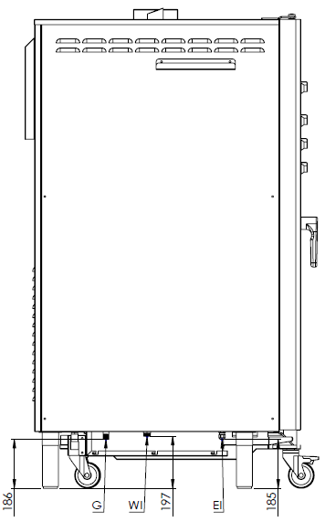

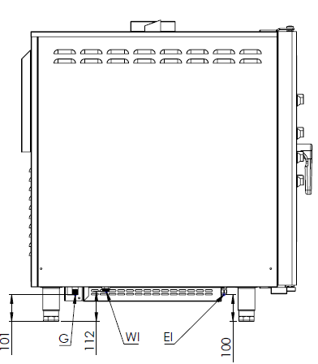

PRİME102GM PRIME202GM

G= Gas connection
WI= Water inlet
EI= Electrical inlet

control panel
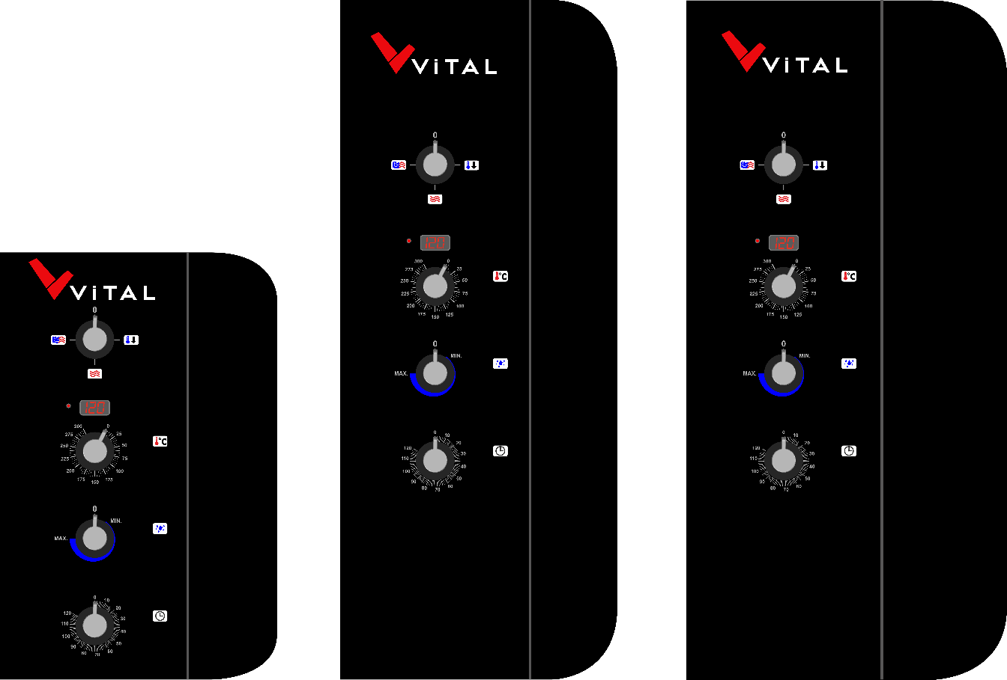

PRIME061GM PRIME101GM PRIME102GM-PRIME202GM

usage
- The device is designed for professional usage and should only be used by trained personnel.
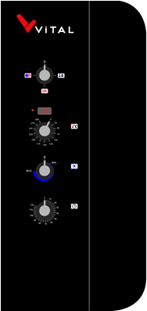

MOD SELECTION BUTTON

THERMOSTAT BUTTON

HUMIDITY BUTTON

TIMER BUTTON

1-) Switching On
Convection Mode
- Plug the device into the power supply and open the gas valve.
- Turn the mode selector switch located on the control panel to clockwise or two stages to counterclockwise to the convection mode. There will be an aural warning. This warning will stop when the required time is adjusted.
- After setting the mode, adjust the time with the timer knob.
- The cooking process will start after closing the door.
- At the end of the cooking period, the oven will give an aural warning.

Half Humidity Mode
- Plug the device into the power supply and open the gas valve.
- Open the water valve to which the device is connected.
- Turn the mode selector switch located on the control panel 3 stages to clockwise or one stage to counterclockwise to the half humidity mode. There will be an aural warning. This warning will stop when the required time is adjusted.
- After setting the mode, adjust the time with the timer knob.
- Turn the steam supply knob to clockwise to give the required amount of steam. To reach that, the cabinet of the oven must be between 85°C – 130°C.
- The cooking process will start after closing the door.
- At the end of the cooking period, the oven will give an aural warning.

Cooling Mode
- Turn the mode selector switch to clockwise for 1 stage. When the required time is set with the time adjusting knob, the aural warning will stop.
- The cooking process will begin after adjusting the required time. At the end of this process, the oven will give an aural warning.

2-) Switching Off
- To turn off the device, set the mod selector button to the “0” position.
- Unplug the power supply connected to the device.
- When not operating, unplug the power supply connection and turn off the gas valve to prevent any gas leakage.

cleanıng
- Disconnect the device from the gas before cleaning.
- Do not wash the device with high pressured water.
- After each operation, clean the device with a cloth dipped in warm soapy water.
- Do not use abrasive detergent or wire brushes when cleaning the device’s surface.

MAINTENANCE AND MALFUNCTION
- The maintenance and the malfunction of the device must be carried out by authorized personnel or by a personnel assigned by the manufacturer.
- All connections and repairs must be carried out by the authorized service centers, otherwise, your device will be out of warranty.

Problems and Solutions
PROBLEM | SOLUTION
“Err” sign and then “GAS” sign appears on the display panel. | Open the gas valve of the locval gas net connected to the device or the LPG tube’s valve. Then set the mode selector to the “0” position. Set the mode selector to the required cooking mode and try again. If the problem continues, please contact the AUTHORIZED SERVICE.
There is an aural warning and “Err” sign on the display panel. | The thermocouple that mesures the temperature of the cabinet is broken or there is a disconnection. Please contact the AUTHORIZED SERVICE.
The oven does not reach the required temperature. | There is a problem with the oven resistances or with the temperature control system. Please contact the AUTHORIZED SERVICE.
The oven is operating even though the door is open. | Check that the oven is not on cooling mode. If the oven is not on cooling mode, there is a problem with the door’s magnetic switch. Please contact the AUTHORIZED SERVICE.
The oven does not give an aural warning at the end of the adjusted time period. | There may be a problem with the buzzer or with its connection. Please contact the AUTHORIZED SERVICE.
In the half steam mode,even though the steam button is on, no steam is generated inside the oven. | Check the water connection valve. If the valve is open and no steam is generated, please contact the AUTHORIZED SERVICE.

WARRANTY CONDITIONS
- According to the consumer rights law and commercial law of the Ministry of Industry, except in a special case of agreement, sold industrial products by our company has one (1) year of warranty and that period starts from the delivery date of the product.
- The warranty includes all the components of the device against fabrication or faulty workmanship, eliminations of the problems or malfunctions of the device caused by the workmanship and installation errors, replacement of non-repairable parts or the mending of repaired parts that can be reused. It also includes repairings or changes of the components by the authorized personnel, or the labor fee due to the problem under the warranty.
- In order for the warranty conditions to be valid, the maintenance of the components fixed to the device, the maintenance of the product, as indicated in the user’s manual, should be done yearly and montly and the information form must be held after the maintenance to be presented when required.
- The document of the replacement of the component has to be presented for parts warranty claims.
- In order to continue the warranty period, the paid periodic maintenance has to be done by the authorized service and the information form must be held to be presented when required.
- In case of any malfunctions under the warranty period, the time spent in the repairment of the device is added to the warranty period. The repair can be maximum 30 (thirty) days. This period starts when the device is on the service station. In case of the absence of this station, the period will start when the manufacturer or the importer is notified by the product seller.
- In accordance with the regulations of the warranty document implementation fundamentals published by the Ministry of Industry, the warranty deed of the industrial products are the purchase invoices.
- If there is any kind of malfunctions due to both the materail and the workmanship, or assembly faults under the warranty period, the necessary replacement and reparing will be done by our authorized personnel without any charge.

Out of Warranty Cases
- If the product is used above its intended purpose, standards or capacity specified by the manufacturer,
- In case of the bad locationing of the product, continuous usage and unhealthy environment (ex: required ventilation), not suitable floor or flat platform, lack of convenient gas pressure,
- If the product hasn’t been used as explained in the instruction manual,
- If the fault is caused by inconvenient, worng or careless usage,
- If the malfunction is caused because of fluctuations in mains electricity, lightning, fire, flood, earthquake and similar natural disasters,
- If the special tools and equipments installed or the maintenance and repair are made by any other person than the authorized person,
- When requesting a service, if the installation-start documents or purchase invoices of the product are not presented,
- If the informations on the documents of the installation, start or maintenance has been destroyed or changed,
- If the paid annual or the contractual periodic maintenance of the product has not been done on time by the authorized personnel,
- If unoriginal spare parts have been used,
- Notifications to our authorized services under the warranty period about the malfunctions that could not have been repaired, will make the time-out of the warranty stop only for that specific malfunction. In this case, the authorized service will inform about the compensation or the non-troubleshooting and the expanded warranty period will end in 3 months in any cases,
- Parts that may have possible abrasion in time such as mouldings, gas burners, lids, adjustmen knobs, flame holder thermocouples etc. will be repaired or changed with a fee.
- Damages caused by the unnecessary loss of time, the maleficience, the revenue loss, or the conduction of the product from the defective location to another,
- Malfunctions of the product due to squalidity are not covered by the warranty,
- The methods to be followed about the fault detection and elimination are determied completely by MUTAŞ’s technical service management and the service matter is taken as basis for the determination of the malfunction.
- In case of detection of the devices with any kind of fluid, warranty conditions will not be valid.

AUTHORIZED SERVICE START-UP PAGE

Start Up Page
- The model and serial number of your device are shown on the “Technical Data” label affixed to the device.
- Select the technical data according to the device model on the nameplate.

MUST BE FILLED BY AUTHORIZED SERVICE!

COMPANY INFORMATIONS | :
PRODUCT | :
MODEL | :
SERIAL NUMBER | :
PRODUCTION DATE | :
SERVICE STAMP AND SIGNATURE | :
PERSONNEL OF THE SERVICE | :
CONTACT
TEL | : 0312 837 76 72
FAX | : 0312 837 73 38
E-MAIL | : teknikservis@vitalmutfak.com

CONTACT

MUTAŞ MUTFAK ISITMA SİSTEMLERİ SAN. PAZ. İNŞ. TUR. İÇ VE DIŞ TİC.LTD.ŞTİ
HEADQUARTER
ADRES: Plevne Cad. No:40 Gülveren / ANKARA

TEL: (0312) 363 99 33 FAX: (0312) 363 94 92

Web: www.vitalmutfak.com E-Mail:info@vitalmutfak.com
MUTAŞ MUTFAK ISITMA SİSTEMLERİ SAN. PAZ. İNŞ. TUR. İÇ VE DIŞ TİC.LTD.ŞTİ
FACTORY
ADRES: Taşpınar Mahallesi Küme Evleri No:154/A Çubuk / ANKARA

TEL: (0312) 837 76 72 FAX: (0312) 837 73 38

Web: www.vitalmutfak.com
E-Mail:teknikservis@vitalmutfak.com

AFTER SALES SERVICE
For the nearest MUTAŞ/VİTAL Authorized Service, please contact the numbers above.
teknikservis@vitalmutfak.com

